Math Circle Problem Set 5. Name:

Problem 5.1: I asked my class to make me some drawings of either machines or animals. If they drew a machine, they were supposed to use red ink. If they drew an animal they can use whatever color of ink they want. For each child, write whether they are following the rule. You can write YES, NO, or CAN’T TELL.

Child | Alice | Ben | Celia | Daniel
Picture | Airplane | Unknown | Unknown | Dog
Ink Color | Unknown | Black | Red | Unknown
Following Rule?

Problem 5.2: The school has a rule “No toys at school”. Principal Korn asked me to make sure all the kids are following the rule. But, I’m missing some information - for some kids I know where they are but I don’t know what’s in their backpack; for other kids I know what’s in their backpack but I don’t know where the kid is.

For each child, write whether they are following the rule. You can write YES, NO, or CAN’T TELL.

Child’s name | Aaron | Barbara | Cedric | Diane
Location | School | ? | ? | Home
Stuff in backpack | ? | Lunch | Toy Car | ?
Following Rule?

Problem 5.3: This is a picture of a machine with four levels, where balls drop from the top level (A) down to the bottom level (G, H, I, J). Each time, there is a 50% chance it goes to the circle to the left, and a 50% chance it goes to the circle to the right. (So if 100 balls start at A, we would expect about 50 of them to go to B, and 50 of them go to C.)

Send a ball through the machine, flipping a coin each time it needs to drop down to the next level to see where it ends up. Heads means to follow the arrow with an H, while tails means to follow the arrow with a T. Send 10 balls through and keep a tally of how many balls end up at each of G, H, I, and J.
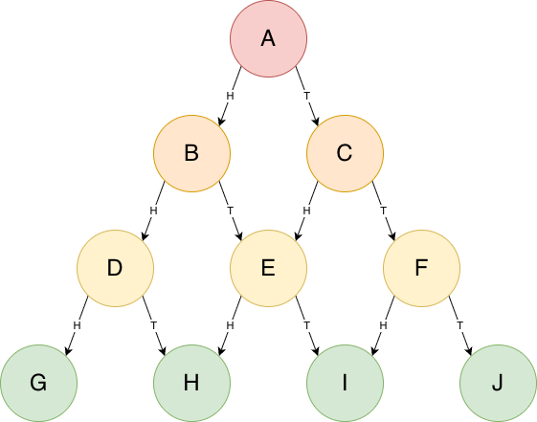

Problem 5.4: How many different paths is it possible for a ball to take on its way to the bottom level? There are only four places a ball can end up (G, H, I, J), but sometimes there is more than one way a ball can get to the same spot. For example, here are two paths that both end up at H: ABEH and ACEH.

What if instead of writing ABEH, we write what the coin flips would have to be in order to take that path? For ABEH, we would need to flip heads/tails/heads, so we could write HTH.

For each path you found, write the matching coin-flips. Did you miss any paths?

Problem 5.5: Giant Bill is hungry for cookies. He wants to eat three sugar cookies and three chocolate cookies, but he can’t decide what order to eat them in. How many options are there?

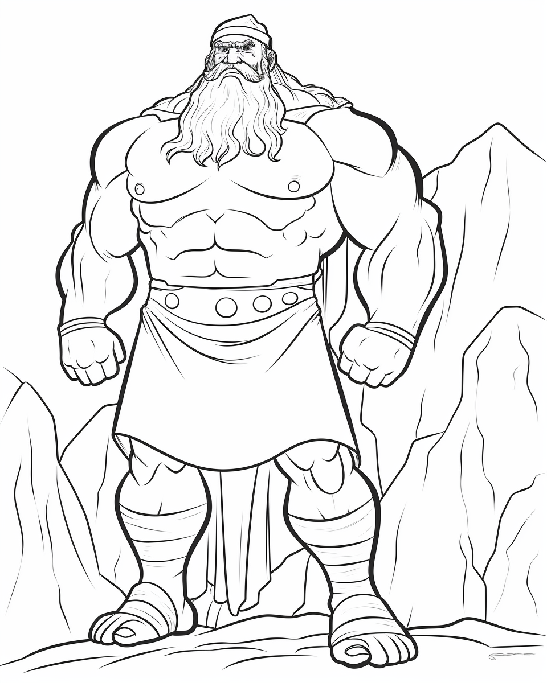 | 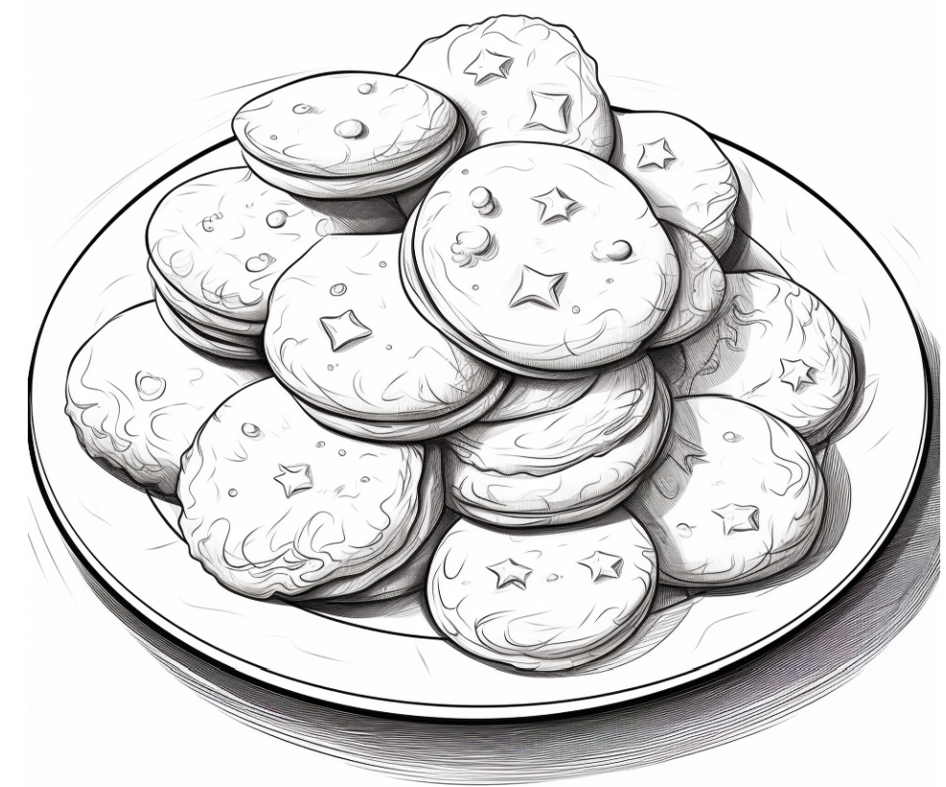 | 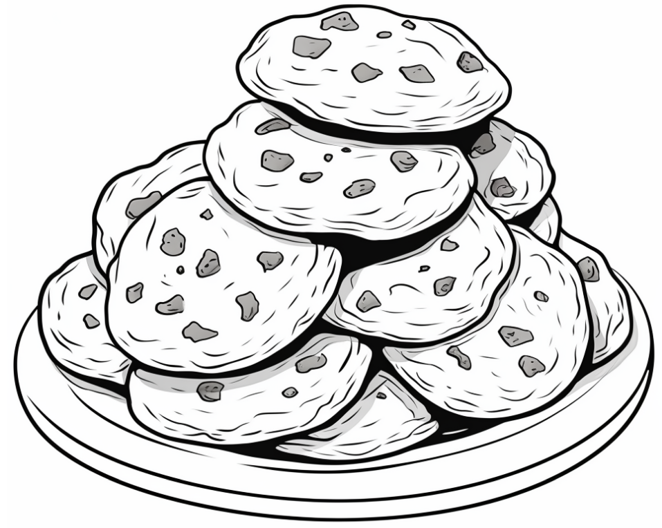

Labeling note: We can use the letters S and C to save space writing down his options. For instance, if he eats all the sugar cookies and then all the chocolate cookies, we could call that SSSCCC. If he goes back and forth from sugar to chocolate chip, we could call that SCSCSC.

Problem 5.6: Mary is walking from her house to her school. Her house (the red square) is three blocks south and three blocks west of her school (the red star). She has to walk six blocks total, but there are lots of options for how she could walk. For instance, she could go three blocks east and then three blocks north (EEENNN). Or she could go two blocks east, three blocks north, one block east (EENNNE).

How many ways can you find for Mary to walk to school? If you run out of space below, you can draw more grids on the back.

(This is the same as problem 4.6 last week, but it’s here again since we didn’t discuss it.)
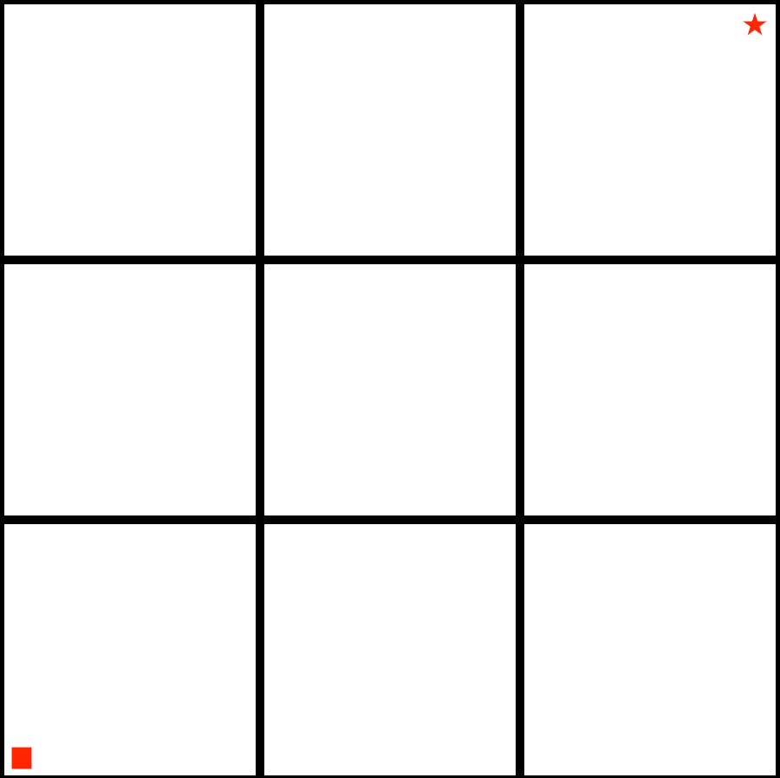

Problem 5.7: I’m playing a solitaire card game with six cards. Each turn, I deal the top card to the keep pile and then put the next card on the bottom of the deck. Here is what would happen if the deck was initially set up as 1 2 3 4 5 6.
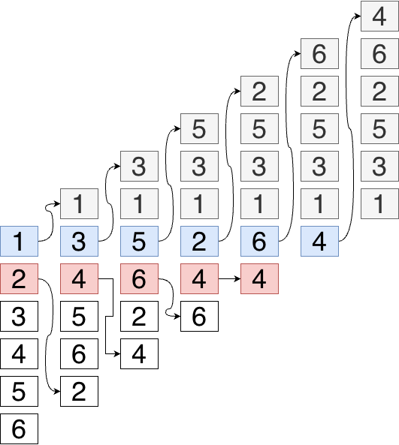

- We deal the 1, and put 2 on the bottom.
- We deal the 3, and put 4 on the bottom.
- We deal the 5, and put 6 on the bottom.
- We deal the 2, and put 4 on the bottom.
- We deal the 6, and put 4 on the bottom. (At this point 4 is the only card, so just put it back into the deck since for a deck with only one card, the top is the bottom.)
Afterwards the keep pile should be 1 3 5 2 6 4.

What order would the cards need to be in for the keep pile to turn out 1 2 3 4 5 6?

